Software Requirement Specifications

AI Based Crop Disease Detection System



Submitted by
Muhabbat Ali Khan (F22BINFT1E02100)

Submitted to

Mr. Muzamil ur Rehman

Department of Information Technology

Faculty of Computing

The Islamia University of Bahawalpur

Meeting Details
Sr No | Details | Date | Supervisor Signature

Summary
This document is the Software Requirement Specification (or SRS) for our new AI project that helps find diseases in crops. The main goal of this system is to help farmers by quickly spotting what’s wrong with their plants just by looking at pictures of the leaves.
We are using Artificial Intelligence and some special image tools to make sure the app can tell exactly what disease a plant has. It doesn't just find the problem, though—it also tells the farmer how to fix it. We really want this to help stop crops from dying, keep people from using too many chemicals/pesticides, and help farms grow more food. This document explains exactly what the app needs to do, how it should work, and how we’re going to build it.

Table of Content
1. Introduction
1.1. Purpose
1.2. Scope
1.3. Product Perspective
1.4. User Characteristics
1.5. Similar Apps and Systems / Literature Review
1.6. Proposed Technologies
2. Requirements
2.1. Functional Requirements
2.1.1. Sign Up
2.1.2. Login
2.1.3. Upload Leaf Image
2.1.4. Disease Detection
2.1.5. View Result and Treatment
2.2. Non-Functional Requirements
3. Use Case
3.1. Sign Up
3.2. Login
3.3. Upload Leaf Image
3.4. Disease Detection
3.5. View Result and Treatment
3.6. Manage Dataset (Admin)
4. Flow Process
5. References

Introduction
Agriculture plays a vital role in the economy, especially in countries like Pakistan where a large population depends on farming. Crop diseases are a major cause of reduced agricultural yield and economic loss. Due to lack of technical knowledge and expert access, farmers often fail to identify diseases at an early stage.
The AI-Based Crop Disease Detection System is developed to solve this problem by using Artificial Intelligence and Image Processing. The system allows farmers to upload images of crop leaves and automatically detects diseases with high accuracy. It also provides disease details and treatment suggestions, making it a reliable decision-support tool for farmers.

Purpose
The purpose of this project is to develop an intelligent system that can.
- Detect and classify crop diseases from leaf images.
- Assist farmers with instant diagnosis.
- Provide disease control and treatment suggestions
- Improve crop yield and reduce financial loss

Scope
The scope of this project includes:
- Detection of crop diseases using leaf images
- Support for selected crops such as wheat, rice, maize, tomato, and potato
- Disease classification using AI models (CNN)
- Display of disease name, confidence level, and treatment advice
Out of Scope:
- Soil analysis
- Weather-based prediction
- Automatic pesticide application

Product Perspective
The system is a standalone AI-based application that integrates:
- Image processing module
- AI disease classification model
- Web-based user interface
- Database for storing user data and results
- It can later be integrated with mobile applications or agricultural advisory platforms.

User Characteristics

User Type | Description
Farmer | Uploads crop images and views results
Admin | Manages system, datasets, and users
Researcher | Improves AI model and dataset
Users are expected to have basic smartphone or web browsing knowledge.

Similar Apps and Systems / Literature Review
Several crop disease detection systems already exist, such as:
- Plantix App
- LeafSnap
- Agri AI systems based on CNN
Shortcomings of existing systems:
- Limited crop coverage
- High cost
- Internet dependency
- Complex interfaces
This project aims to provide a simple, low-cost, and accurate solution.

Proposed Technologies

Category | Technology
Programming Languages | Dart, Python
AI/ML Libraries | Tensorflow, Keras, OpenCV
Web Framework | FastAPI
Front-End | Flutter
Database | PostgreSQL
Dataset | PlantVillage Dataset
Platform | Mobile

Requirements
The system will allow users to register, log in, upload images of crop leaves, and receive disease detection results. AI models will analyze the images and provide accurate predictions along with treatment suggestions. Admin users will manage datasets and system configurations.

Functional Requirements

Sign Up
- Name: FR001
- Purpose: Allows a new user to register in the system.
- User(s): Farmer, Admin
- Input:
  - Name
  - Email
  - Password (minimum 8 characters)
  - Phone Number
- Output:
  - User account created successfully

Login

- Name: FR002
- Purpose: Allows registered users to log into the system.
- User(s): Farmer, Admin
- Input:
  - Email
  - Password
- Output:
  - Access to system dashboard

Upload Leaf Image
- Name: FR003
- Purpose: Upload crop leaf image for analysis.
- User(s): Farmer
- Input:
  - Leaf Image (JPEG/PNG)
- Output:
  - Image successfully uploaded

Disease Detection
- Name: FR004
- Purpose: Analyze the image using AI model.
- User(s): System
- Input:
  - Uploaded image
- Output:
  - Disease name and confidence level

View Result and Treatment
- Name: FR005
- Purpose: Display disease details and treatment suggestions.
- User(s): Farmer
- Output:
  - Disease description
  - Recommended treatment

Non-Functional Requirements
- The system should provide results within 5 seconds
- Accuracy should be above 85%
- The system should be user-friendly
- Secure user authentication
- High availability and reliability
- Scalable for future crops and diseases

Use Case

Sign Up

Field | Description
Name | Sign Up
Description | User registration process
Actors(s) | Farmer, Admin
Precondition | User is not registered
Postcondition | User account created

- Basic Flow:
  - User enters registration details
  - System validates input
  - System creates user account
- Alternative Flow:
  - Admin creates user manually
- Exceptions:
  - Invalid input
  - System failure
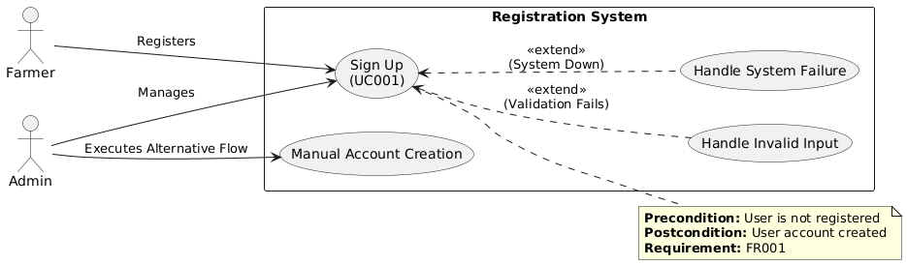

Login

Field | Description
Name | Login
Description | Registered users log into the system
Actors(s) | Farmer, Admin
Precondition | User must be registered
Postcondition | User is redirected to dashboard

- Basic Flow
  - User enters email and password
  - System validates credentials
  - System grants access
- Alternative Flow
  - Admin logs in using administrator credentials
- Exceptions
  - Invalid email or password
  - System failure
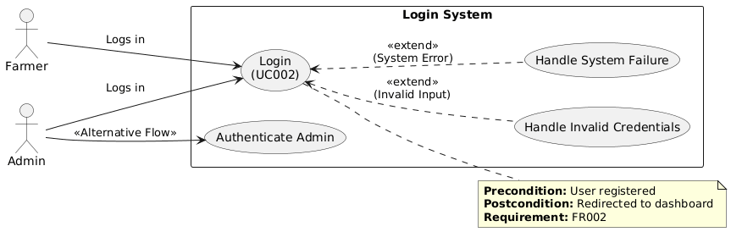

Upload Leaf Image

Field | Description
Name | Upload Leaf Image
Description | Farmer uploads an image of a crop leaf
Actors(s) | Farmer
Precondition | User must be logged in
Postcondition | Image is stored for analysis

- Basic Flow
  - Farmer selects image from device
  - System checks image format
  - Image is uploaded successfully
- Exceptions
  - Unsupported file format
  - Image upload failure
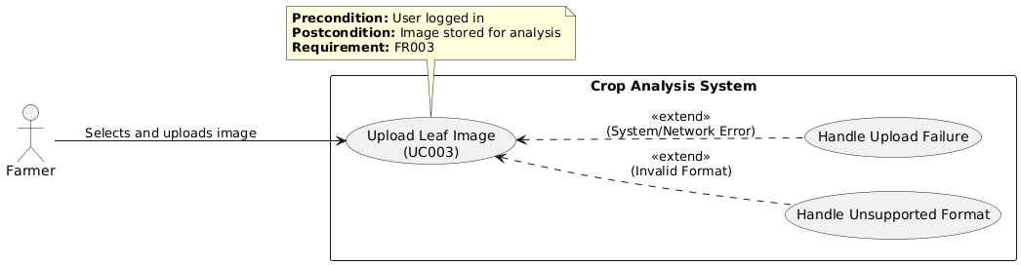

Disease Detection

Field | Description
Name | Disease Detection
Description | AI model analyzes the uploaded image
Actors(s) | System
Precondition | Leaf image must be uploaded
Postcondition | Disease is detected

- Basic Flow
  - System preprocesses the image
  - CNN model predicts the disease
  - Confidence score is generated
- Exceptions
  - AI model failure
  - Corrupted image
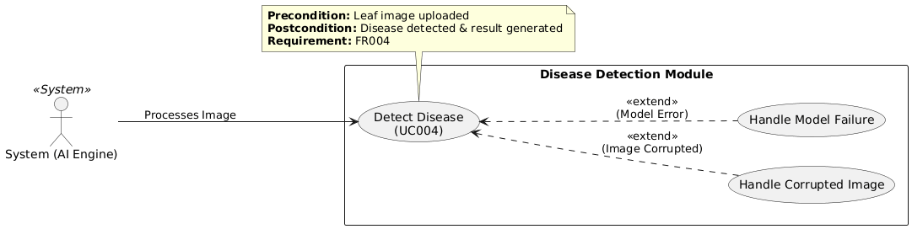

View Result and Treatment

Field | Description
Name | View Result and Treatment
Description | Display detected disease and treatment suggestions
Actors(s) | Farmer
Precondition | Disease detection is completed
Postcondition | User views diagnosis and recommendations

- Basic Flow
  - System displays disease name
  - System shows confidence level
  - System suggests treatment options
- Exceptions
  - No disease detected
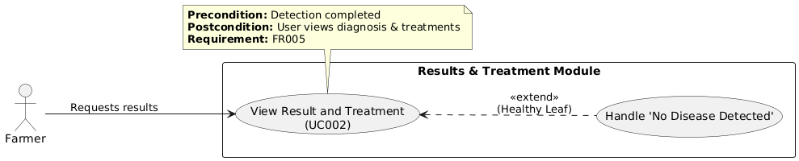

Manage Dataset (Admin)

Field | Description
Name | Manage Datasets
Description | Admin manages crop disease dataset
Actors(s) | Admin
Precondition | Admin is logged in
Postcondition | Dataset is updated

- Basic Flow
  - System displays disease name
  - System shows confidence level
  - System suggests treatment options
- Exceptions
  - No disease detected
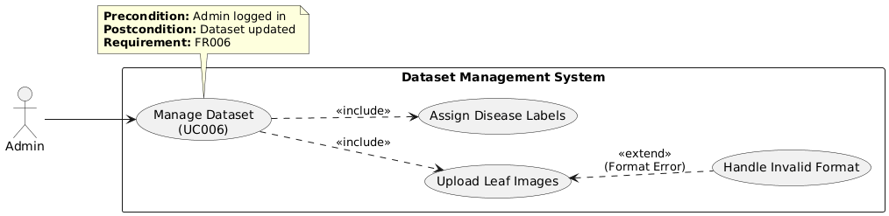

Flow Process
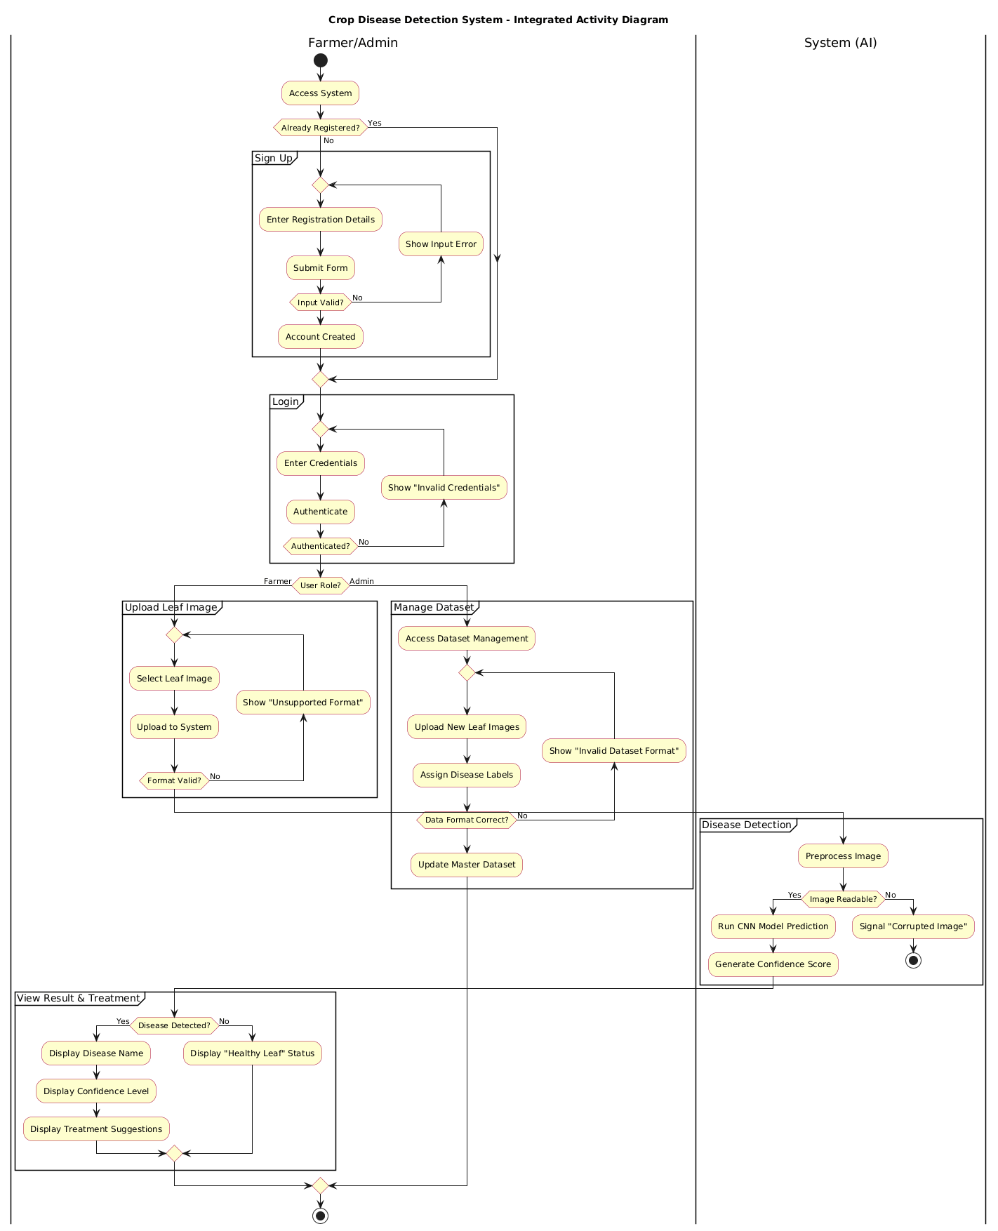

References
  - Mohanty, S. P., Hughes, D. P., & Salathé, M. “Using Deep Learning for Image-Based Plant Disease Detection,” Frontiers in Plant Science, IEEE.
  - TensorFlow Documentation, IEEE Format.
  - PlantVillage Dataset Research Papers.

